**Lab 6: IP**

University of Windsor

Department of Electrical and Computer Engineering

ELEC 8560 – Computer Networks

Semester: Fall 2023

**Student Name**: Amey Mahendra Thakur

**Student number**: 110107589

**Answers:**

1. The IP address of my computer is **198.168.2.95.**

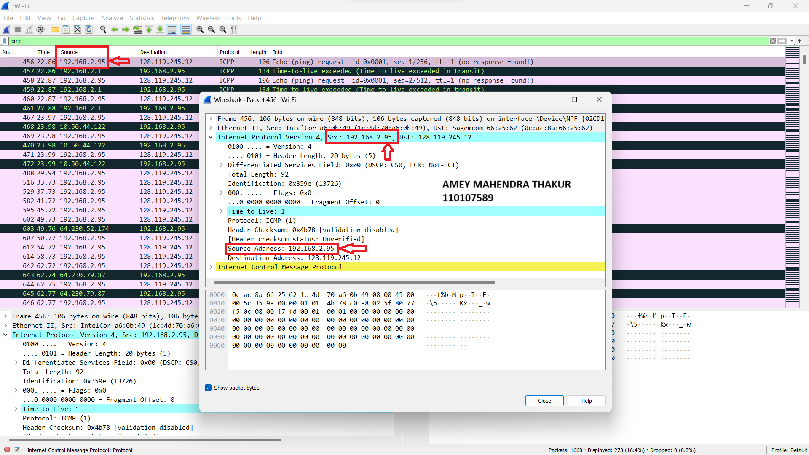

1. The value in the time-to-live (TTL) field in this IPv4 datagram’s header is **1.**

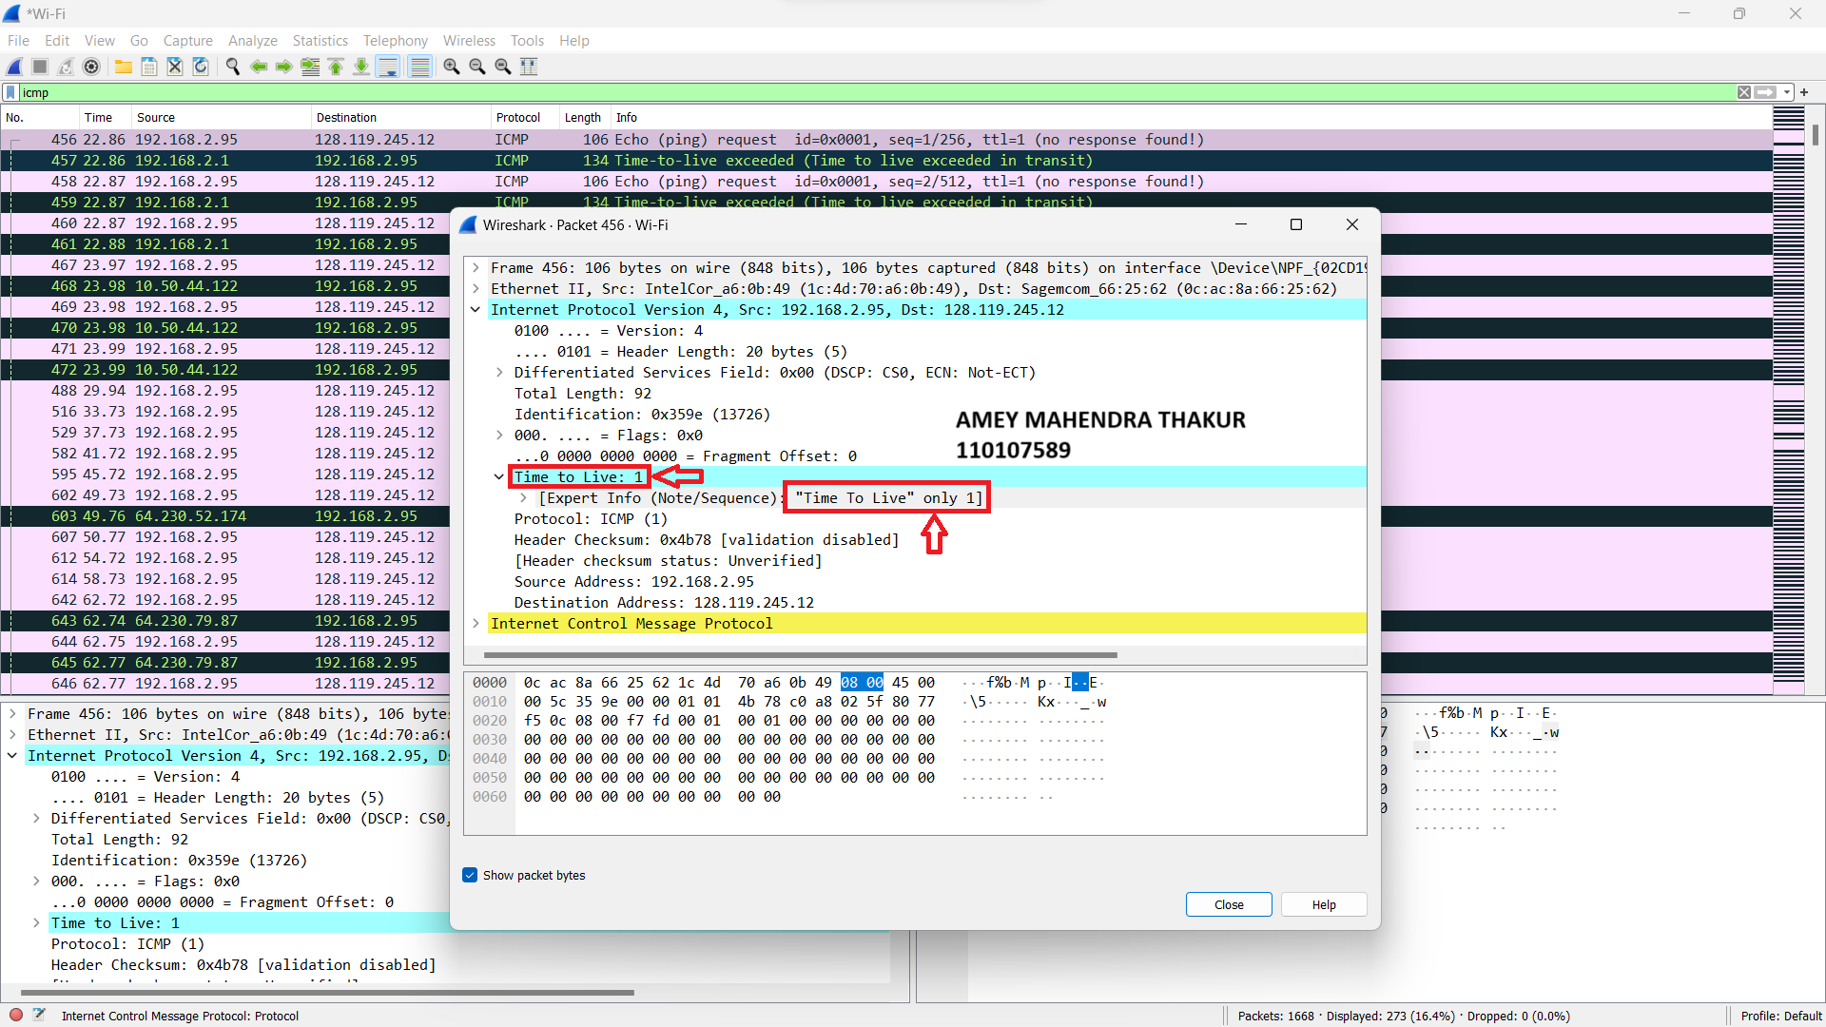

1. The value in the upper layer protocol field in this IPv4 datagram’s header is **ICMP (1).**

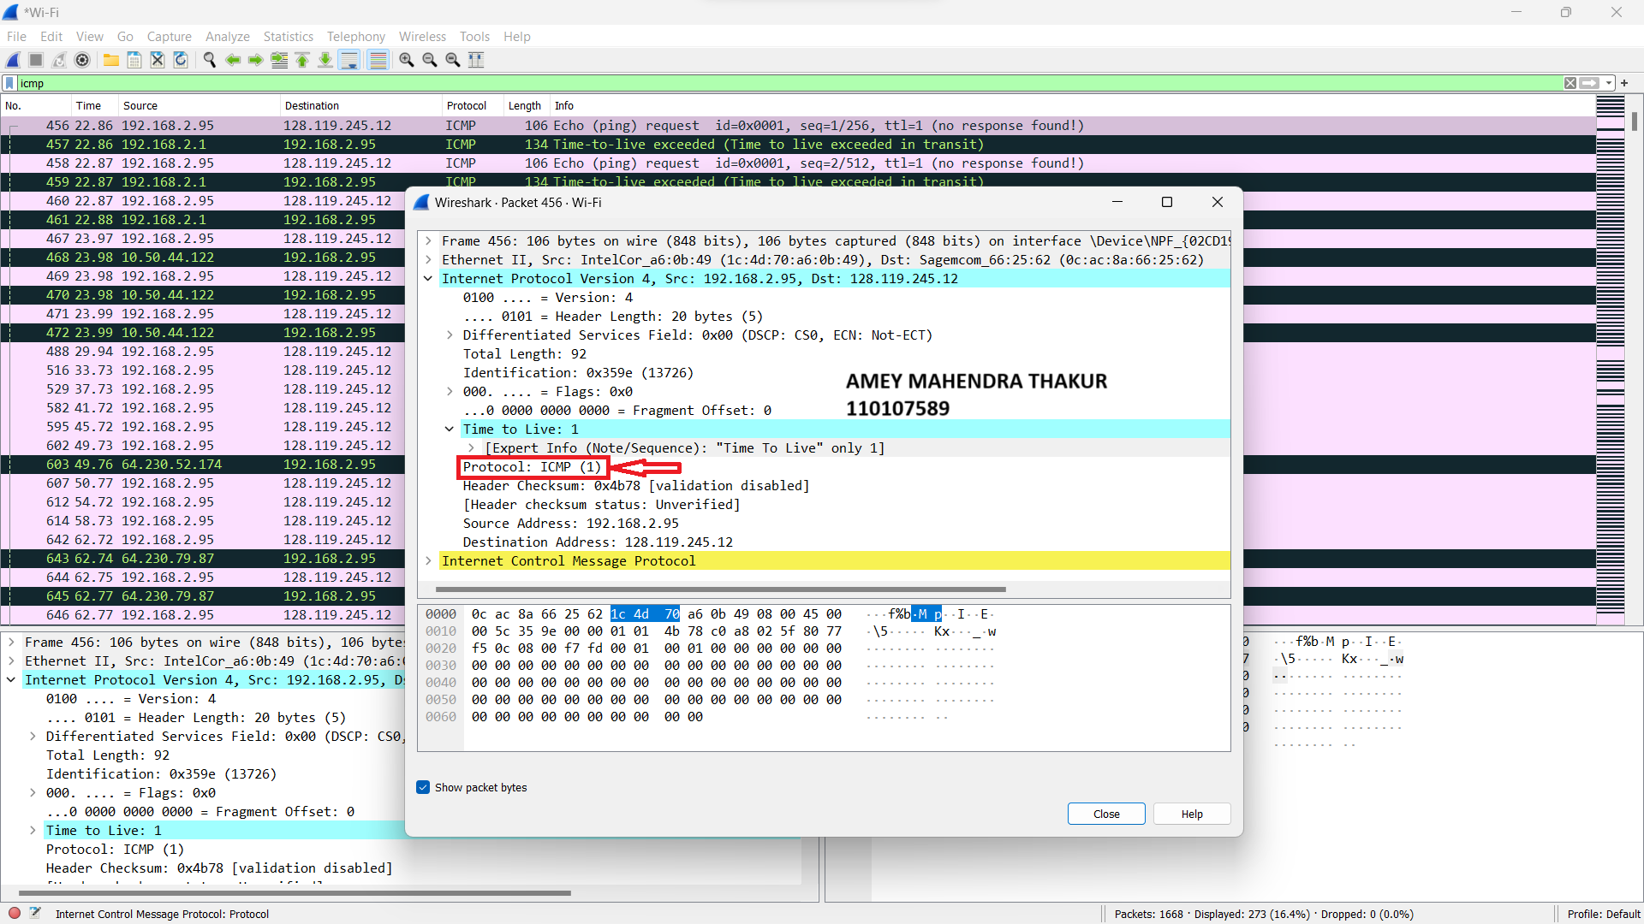

1. There are **20 bytes** in the IP header.

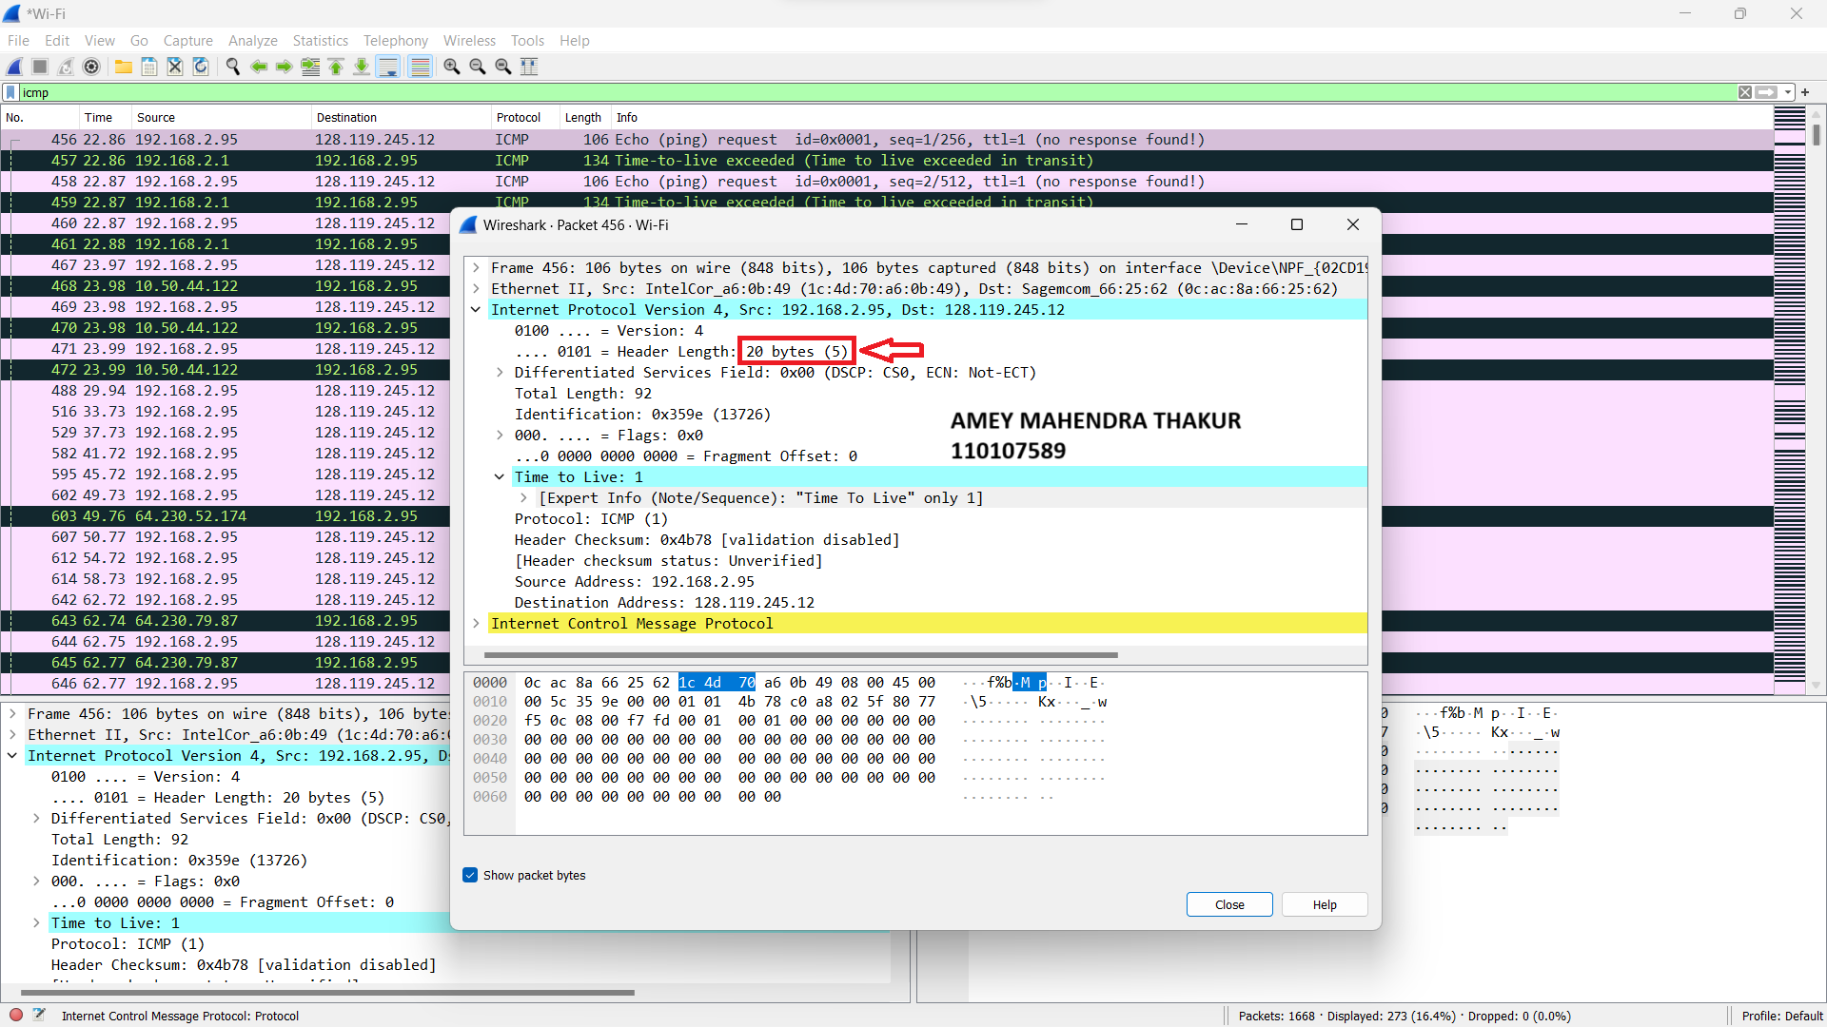

1. The header length of IPV4 datagram is 20 bytes and total length of the datagram is 92 bytes.

The length of IP datagram payload is calculated as below:

IP datagram payload length = total length - header length

= 92 – 20

IP datagram payload length **= 72 bytes**

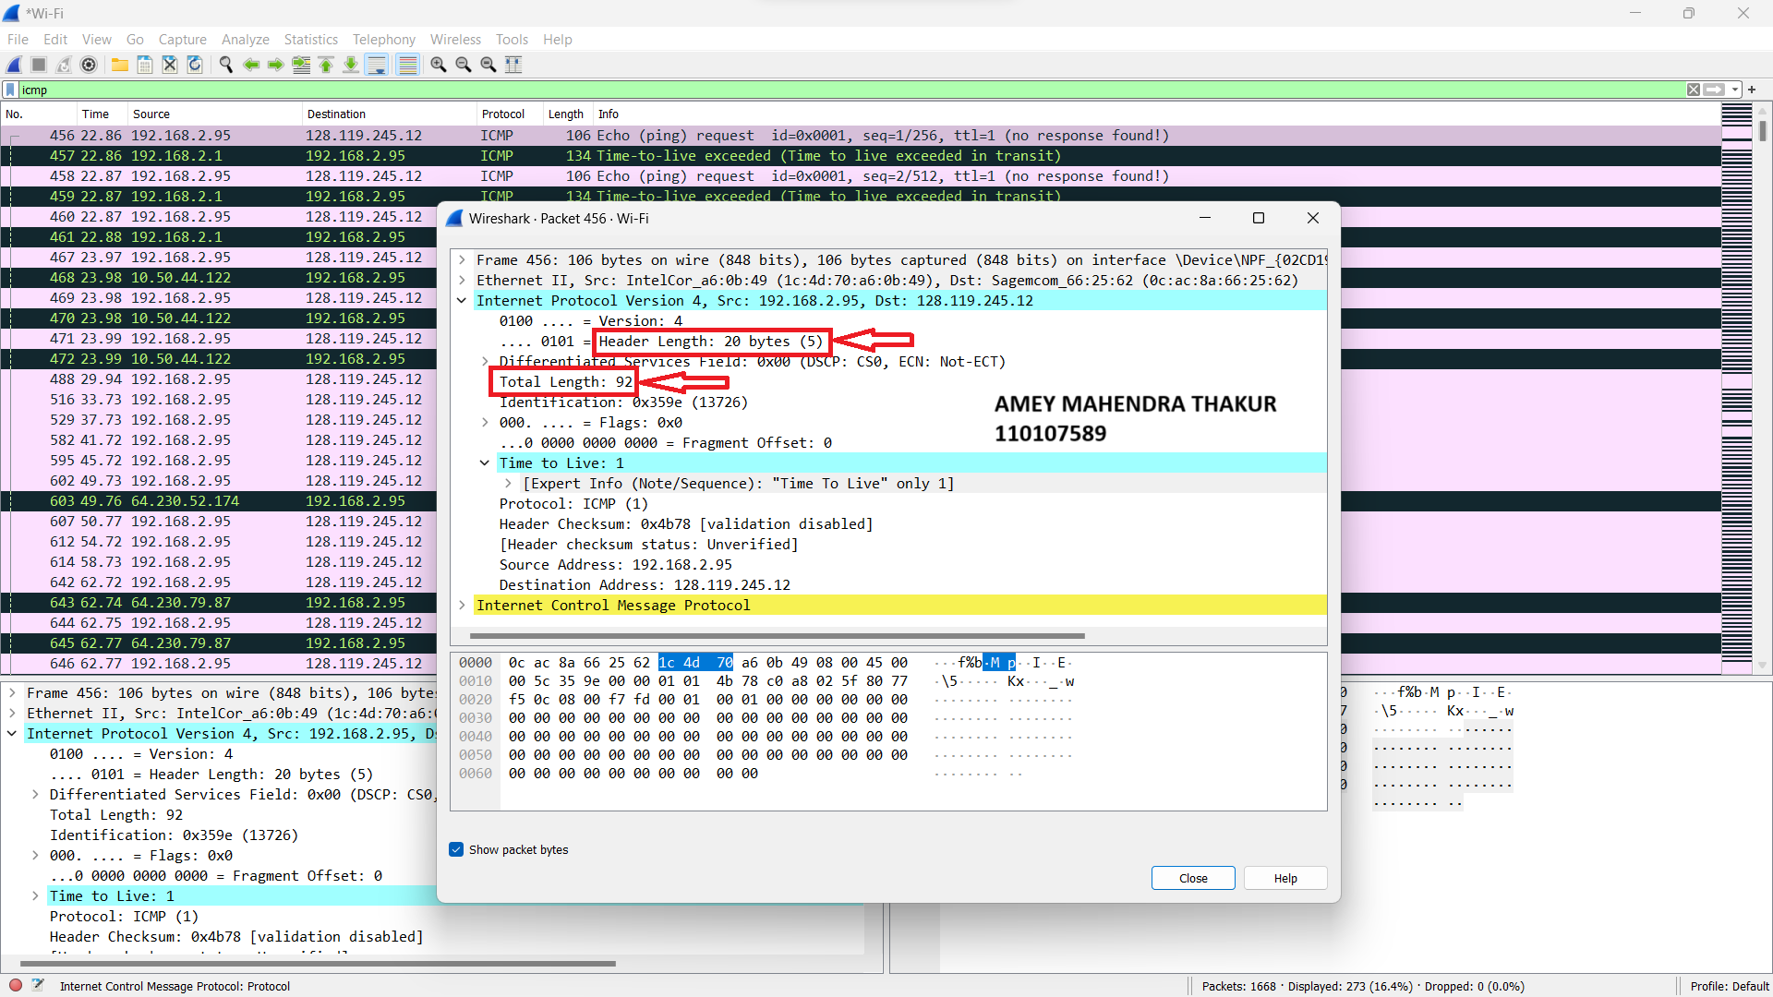

1. In the flags section, we can see the flag set to 0 for more fragments. So the IP datagram is not fragmented.

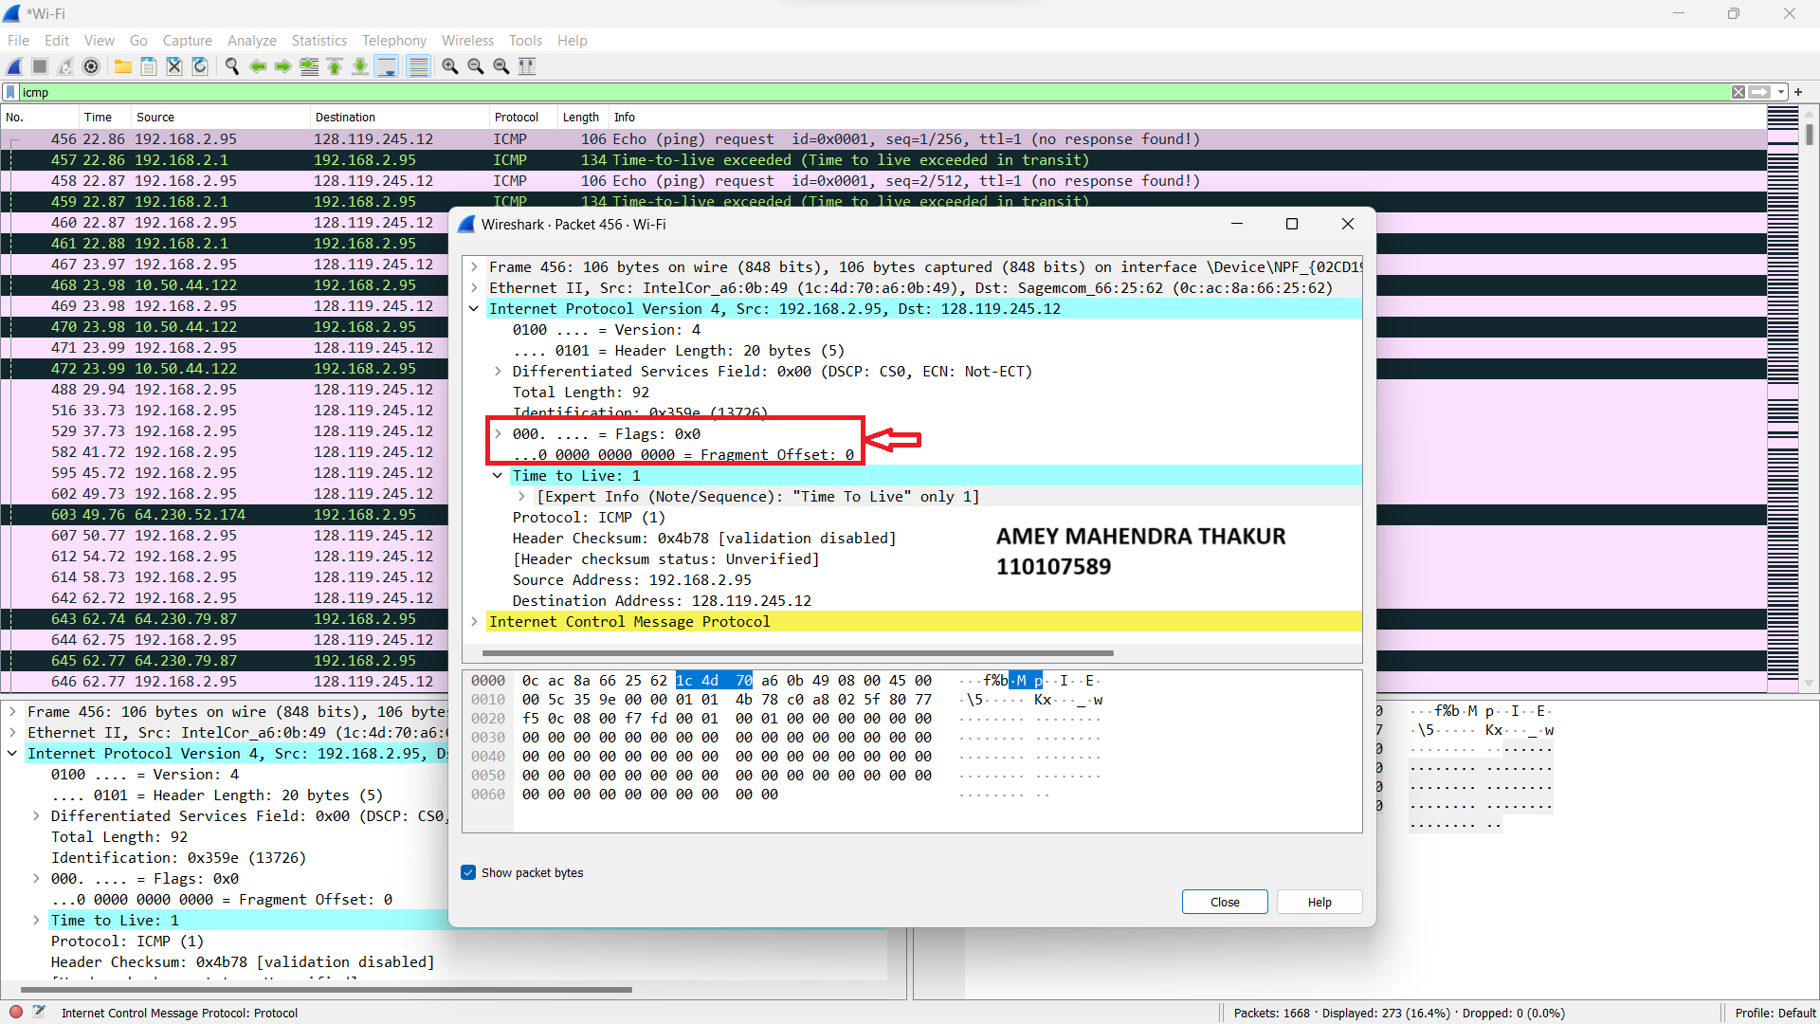

1. When examined a series of segments sent by my computer via traceroute, I found that the Identification and Time-to-live fields of IP datagram **keeps on incrementing** uniformly by a value 1 from ttl=1 to so on.

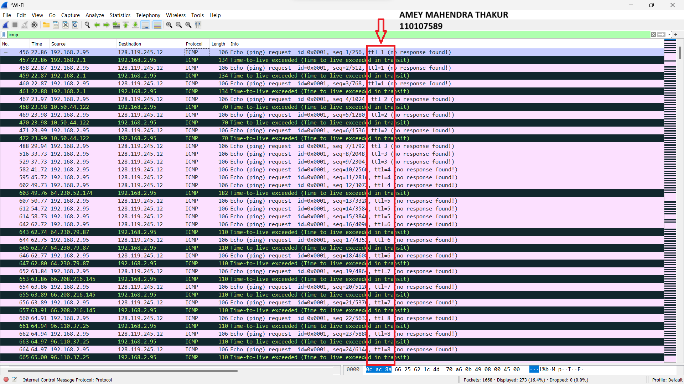

1. The following fields remain constant:
2. version (Will not change because we always used IPv4)
3. header length (Will not change because we always used IPv4)
4. source IP (Will not change because my computer’s IP address doesn’t change)
5. destination IP (Will not change because destination’s(gaia.cs.umass.edu) IP address doesn’t change)
6. differentiated services (Will not change because we are using same protocol every time)
7. upper layer protocol (Will not change because we are using same protocol every time)
8. header checksum (Will not change because the verification is disabled in my tests)

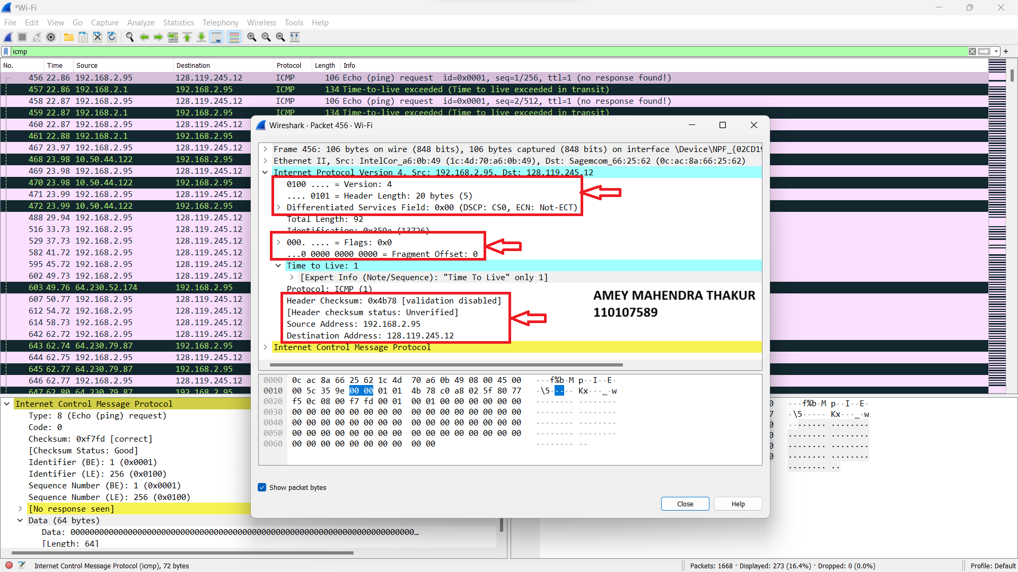

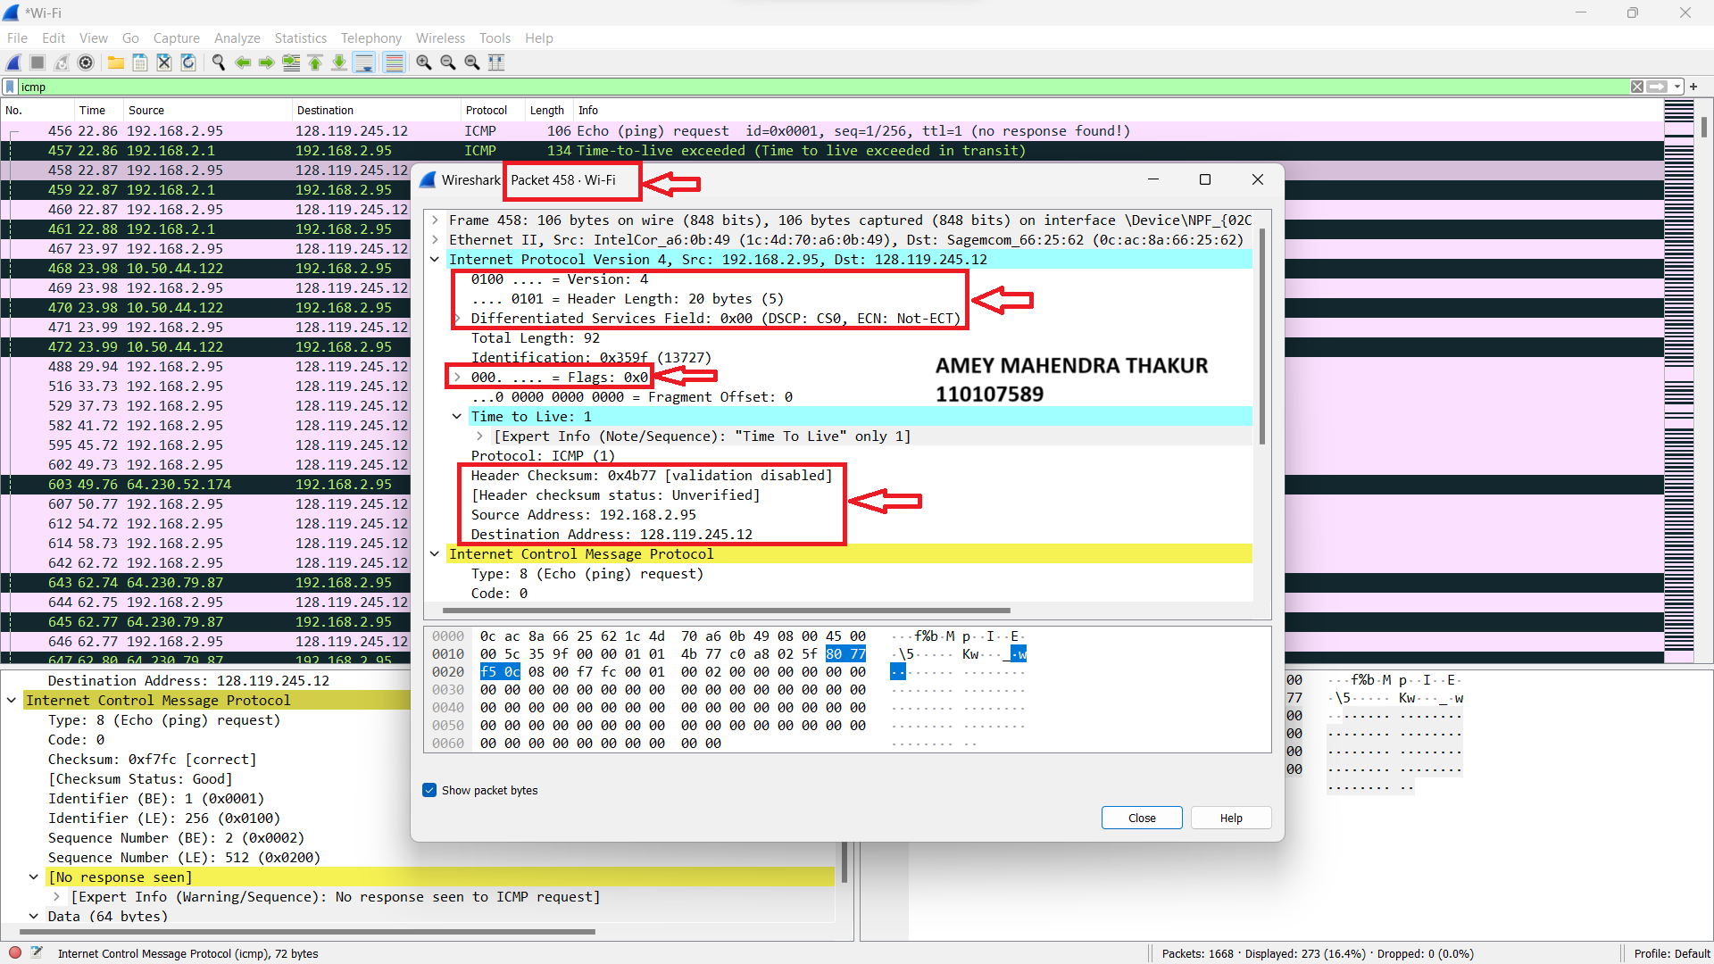

1. The identification field increases by one value for each request going forward. In the below screenshots, the first one has identification field as **0*13732** and second one has **0*13733.**

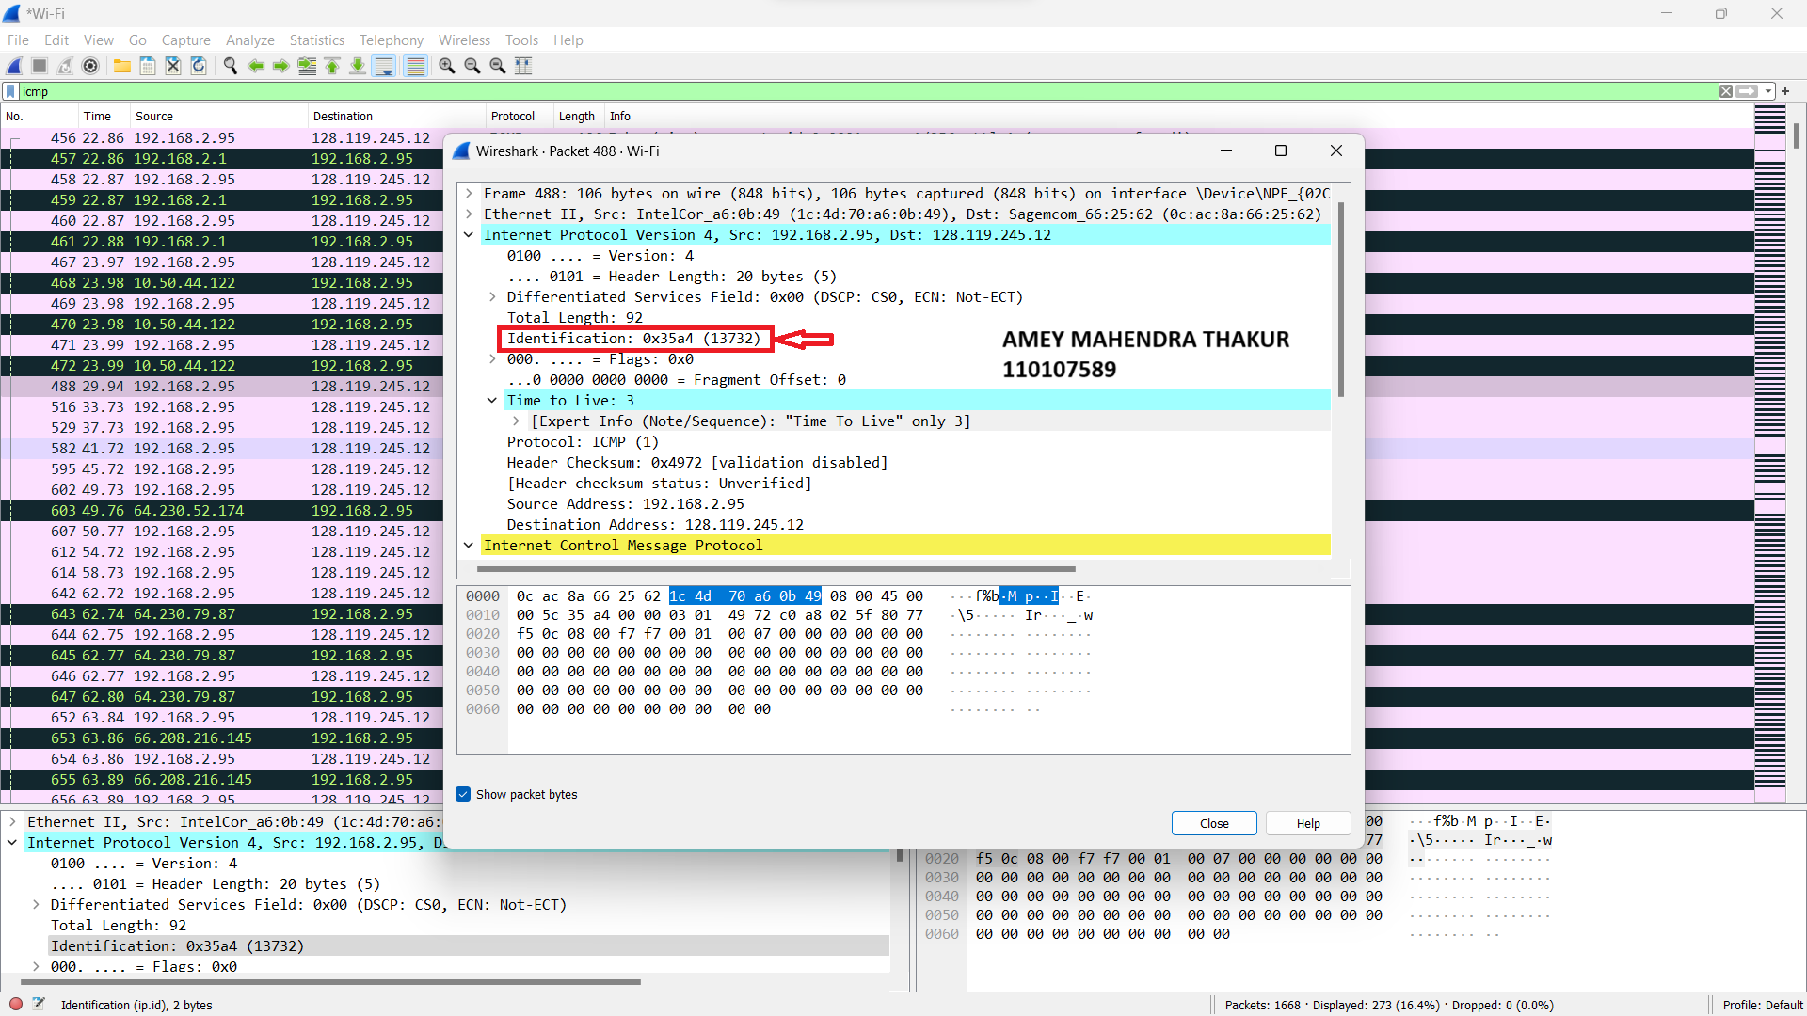

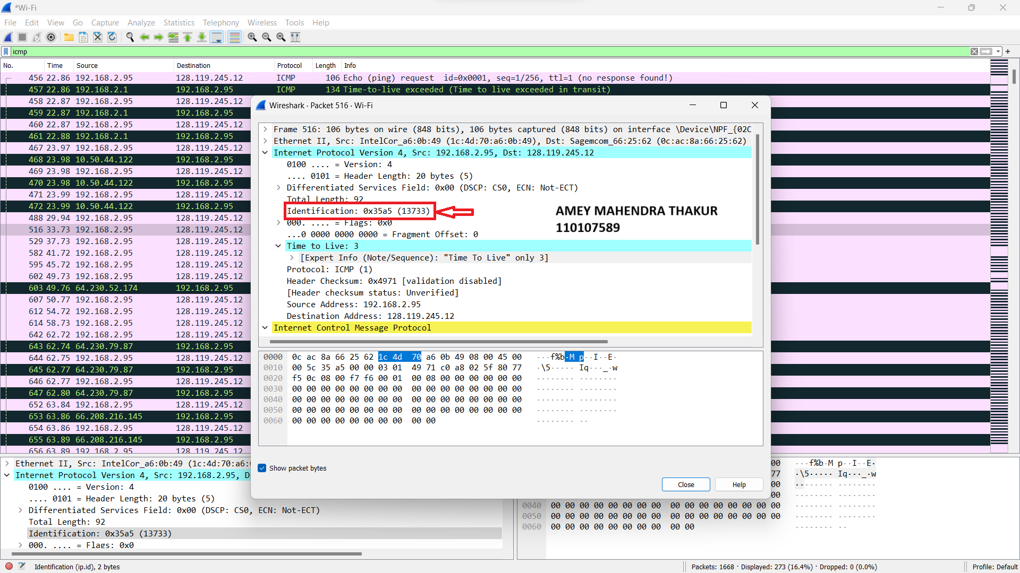

1. The upper layer protocol specified in the IP datagrams returned from the routers is **ICMP.**

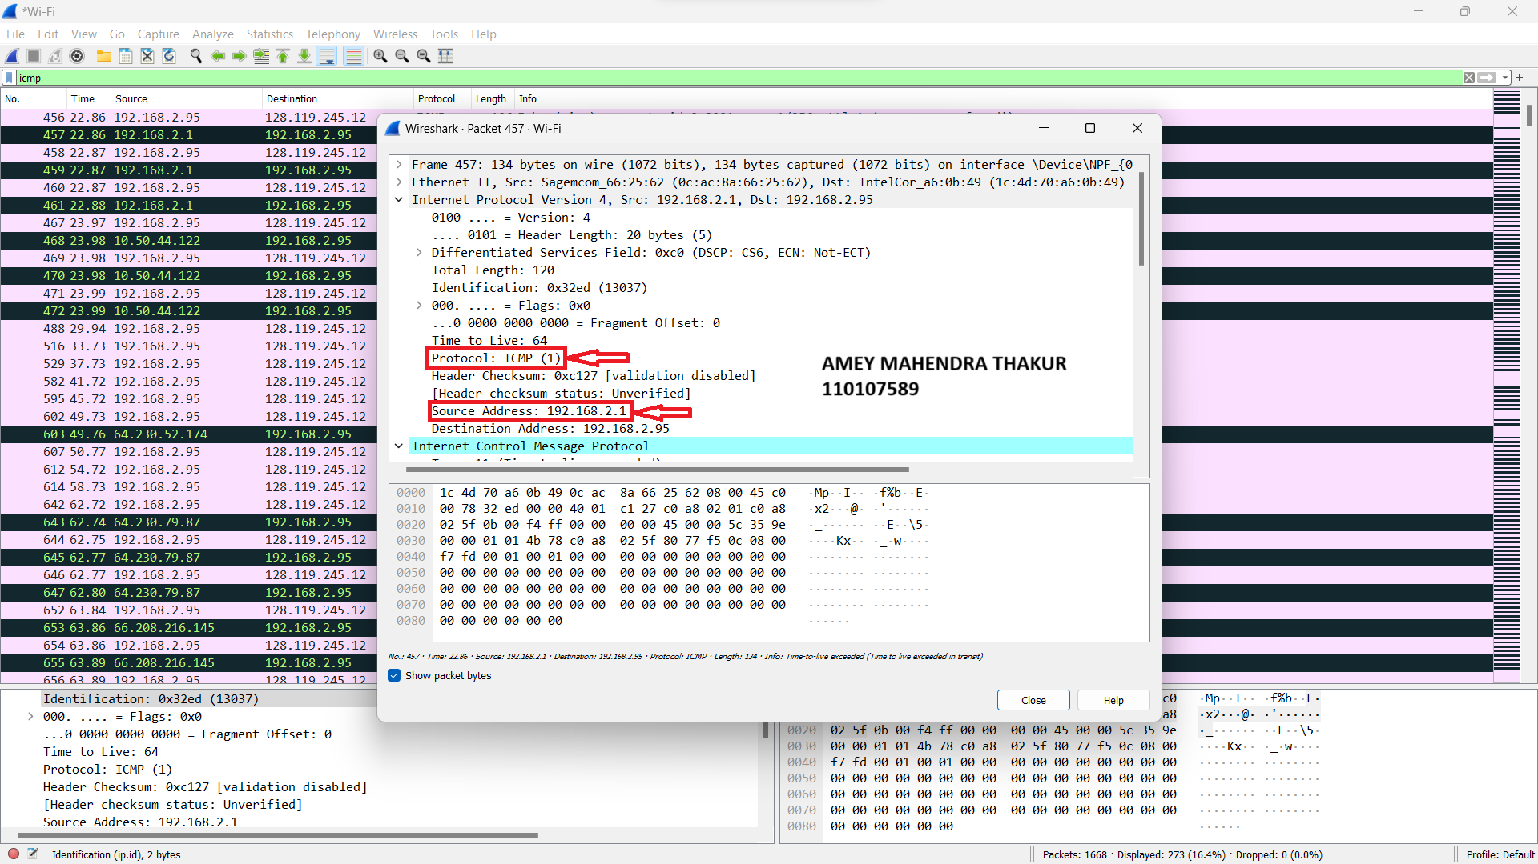

1. When we observe the sequence of ICMP packets from all the routers, the values identification field do not follow any pattern. For example, below screenshots are taken with TTL , the value of identification found to have no pattern. This is unlike the request packets which we observed in question 9.

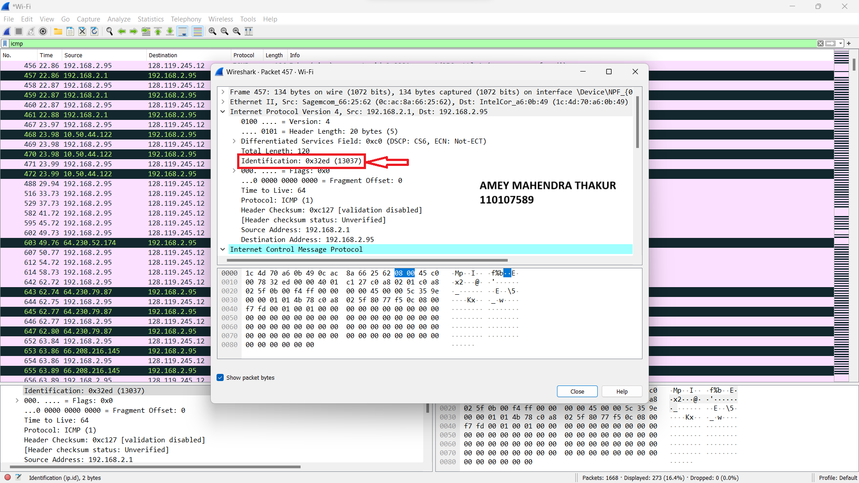

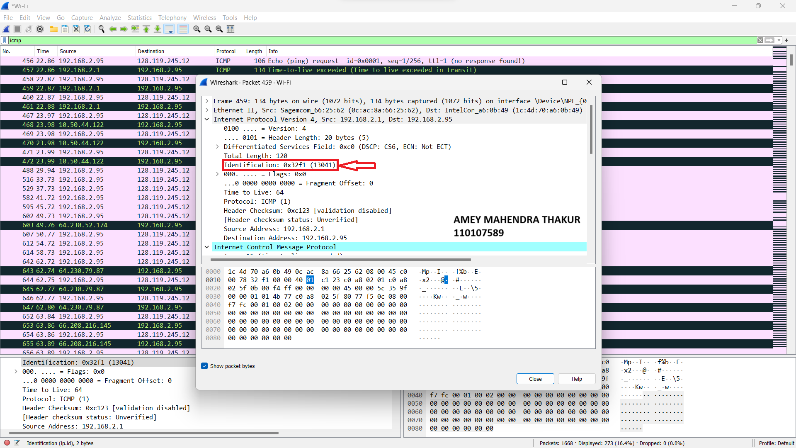

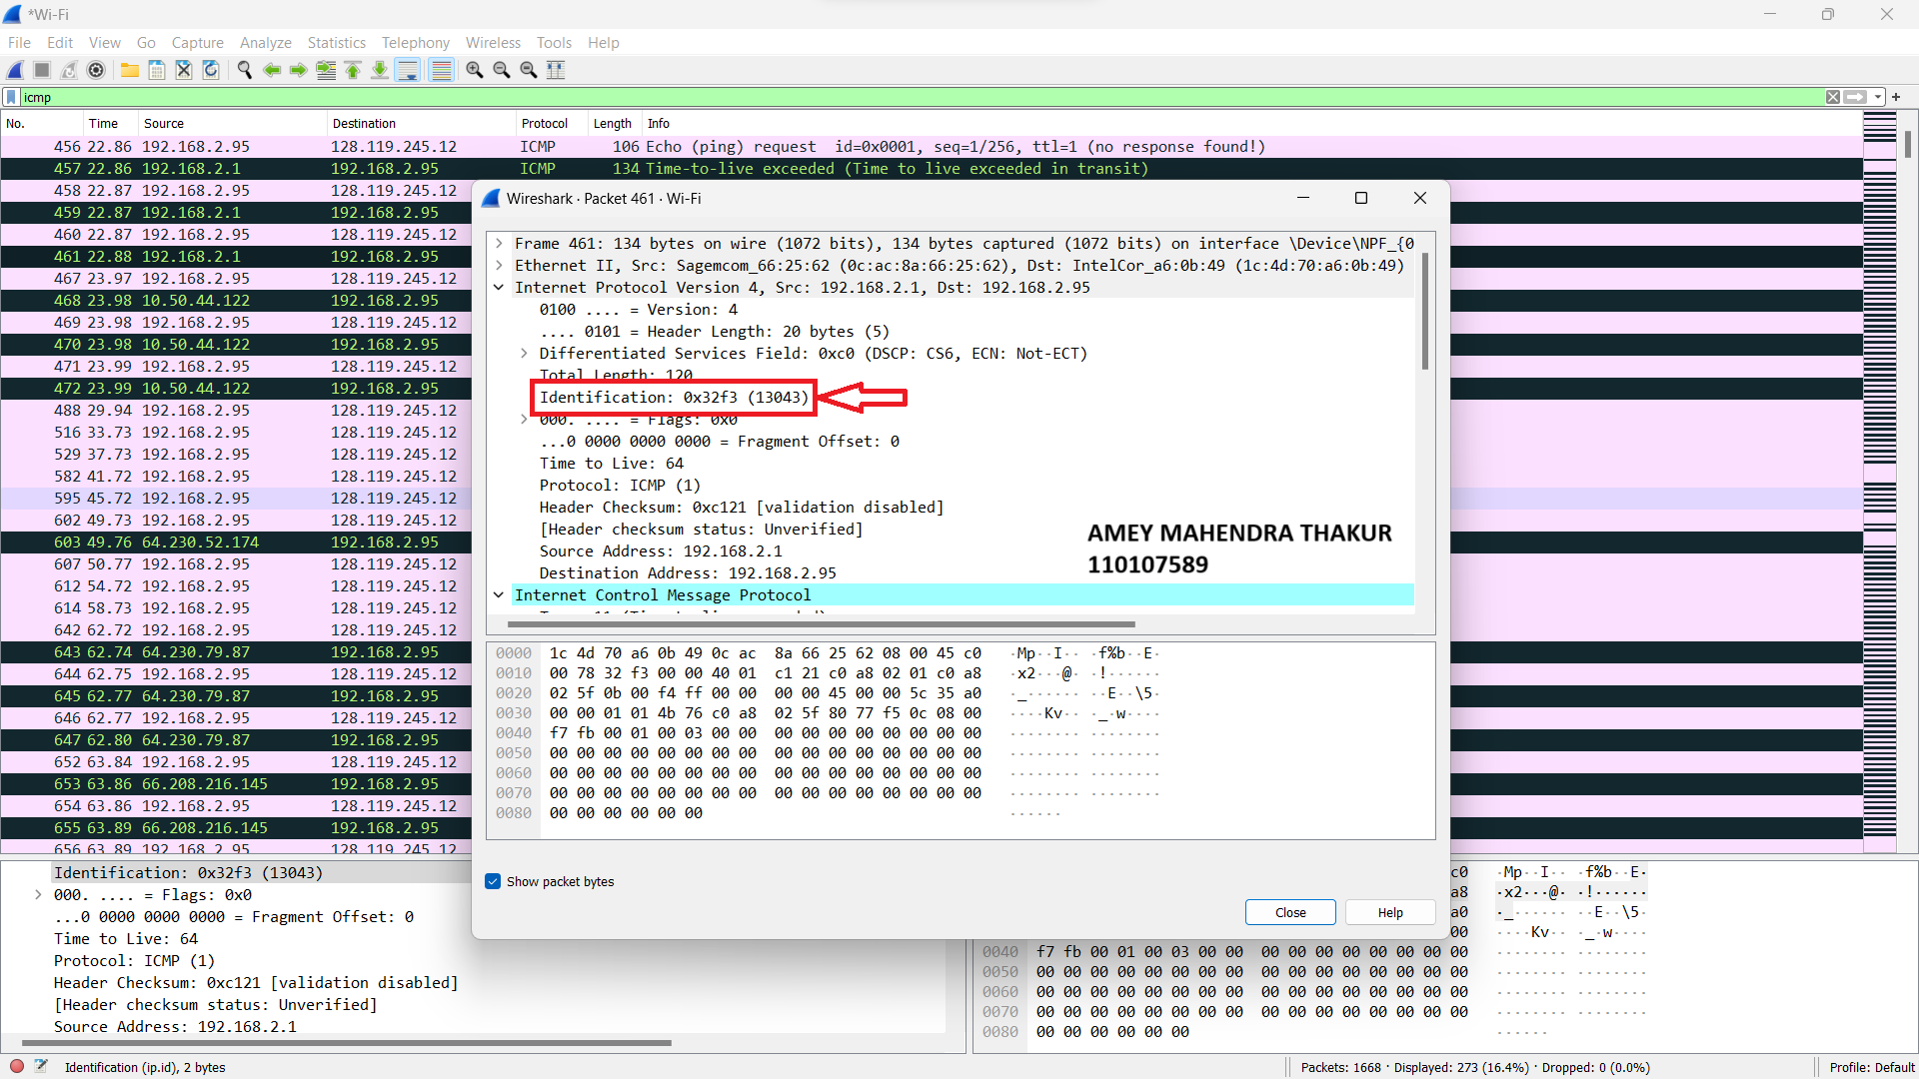

1. The TTL values are the same for the response sent by each router to the 3 ICMP request messages that were sent. In the below screenshots, the TTL of 3 request messages is 64, which is same as that of 3 responses.

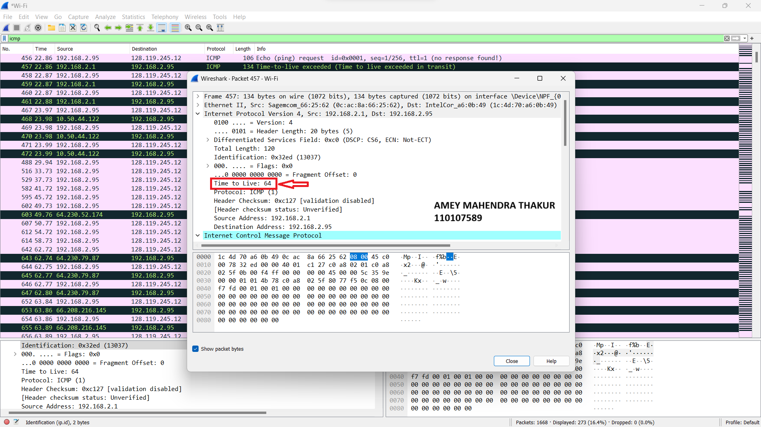

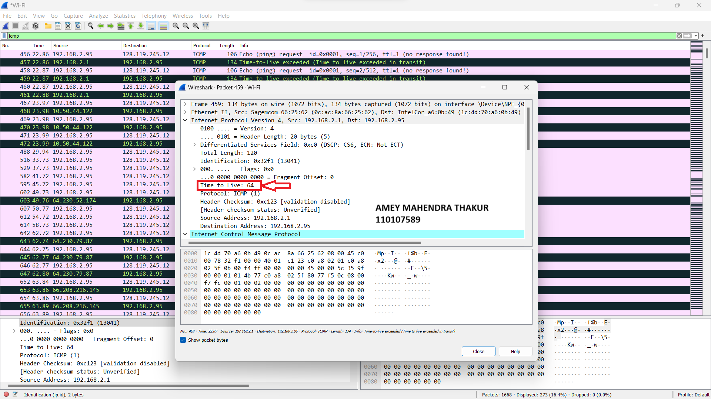

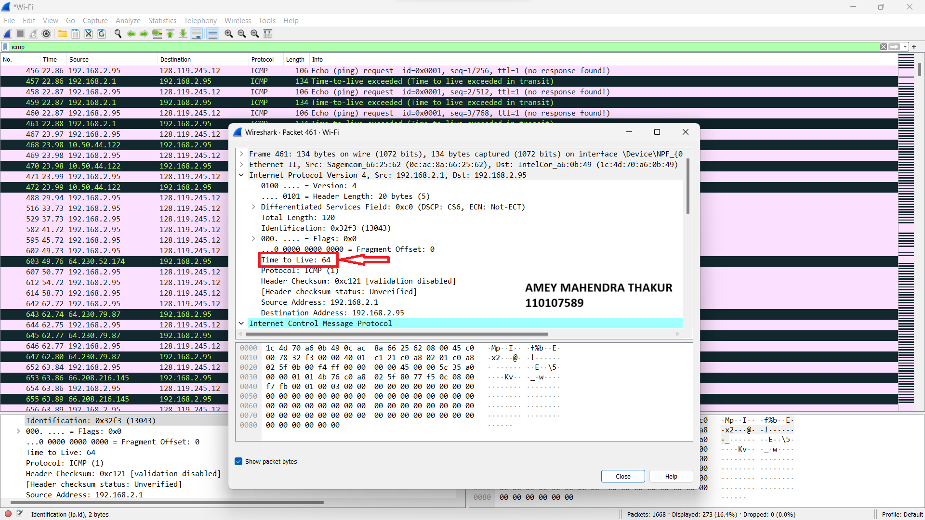

1. Yes, the segment has been fragmented into 3 fragments. In the below screenshots, these datagrams are packets 179, 180, and 181.

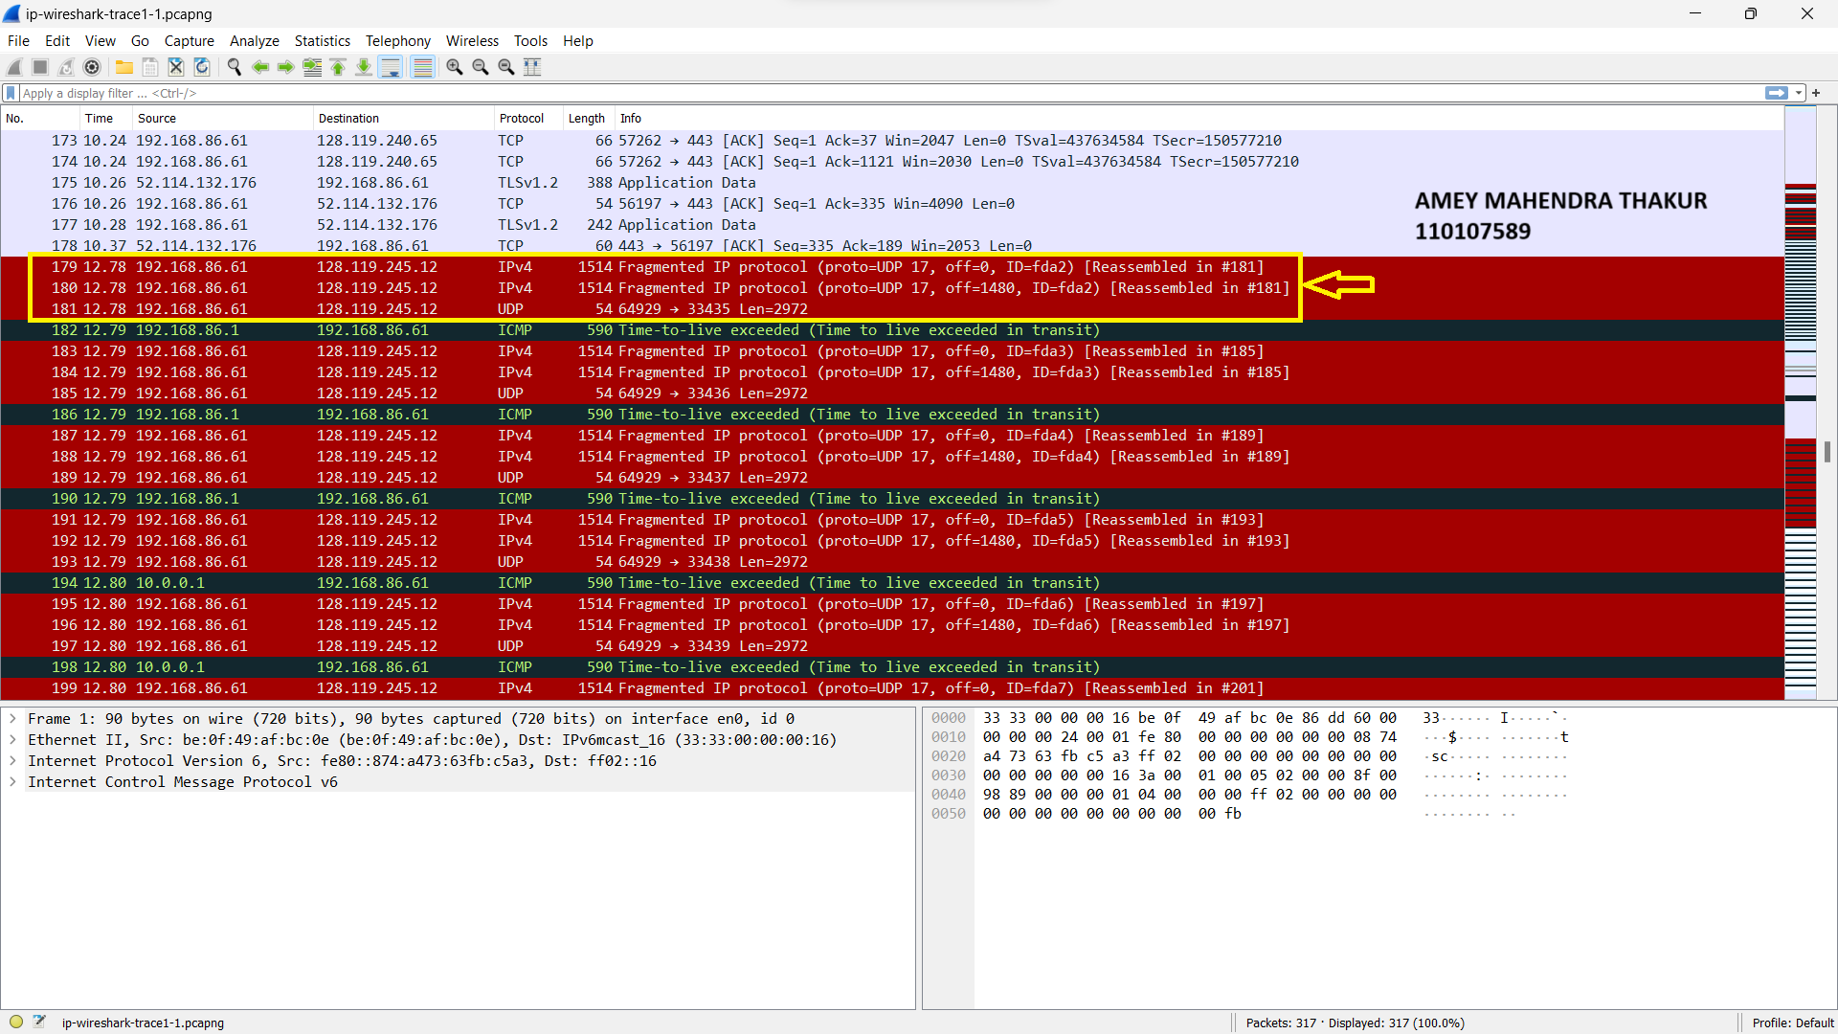

1. The “more segments” flag is SET in the below screenshot indicates that this datagram is fragmented.

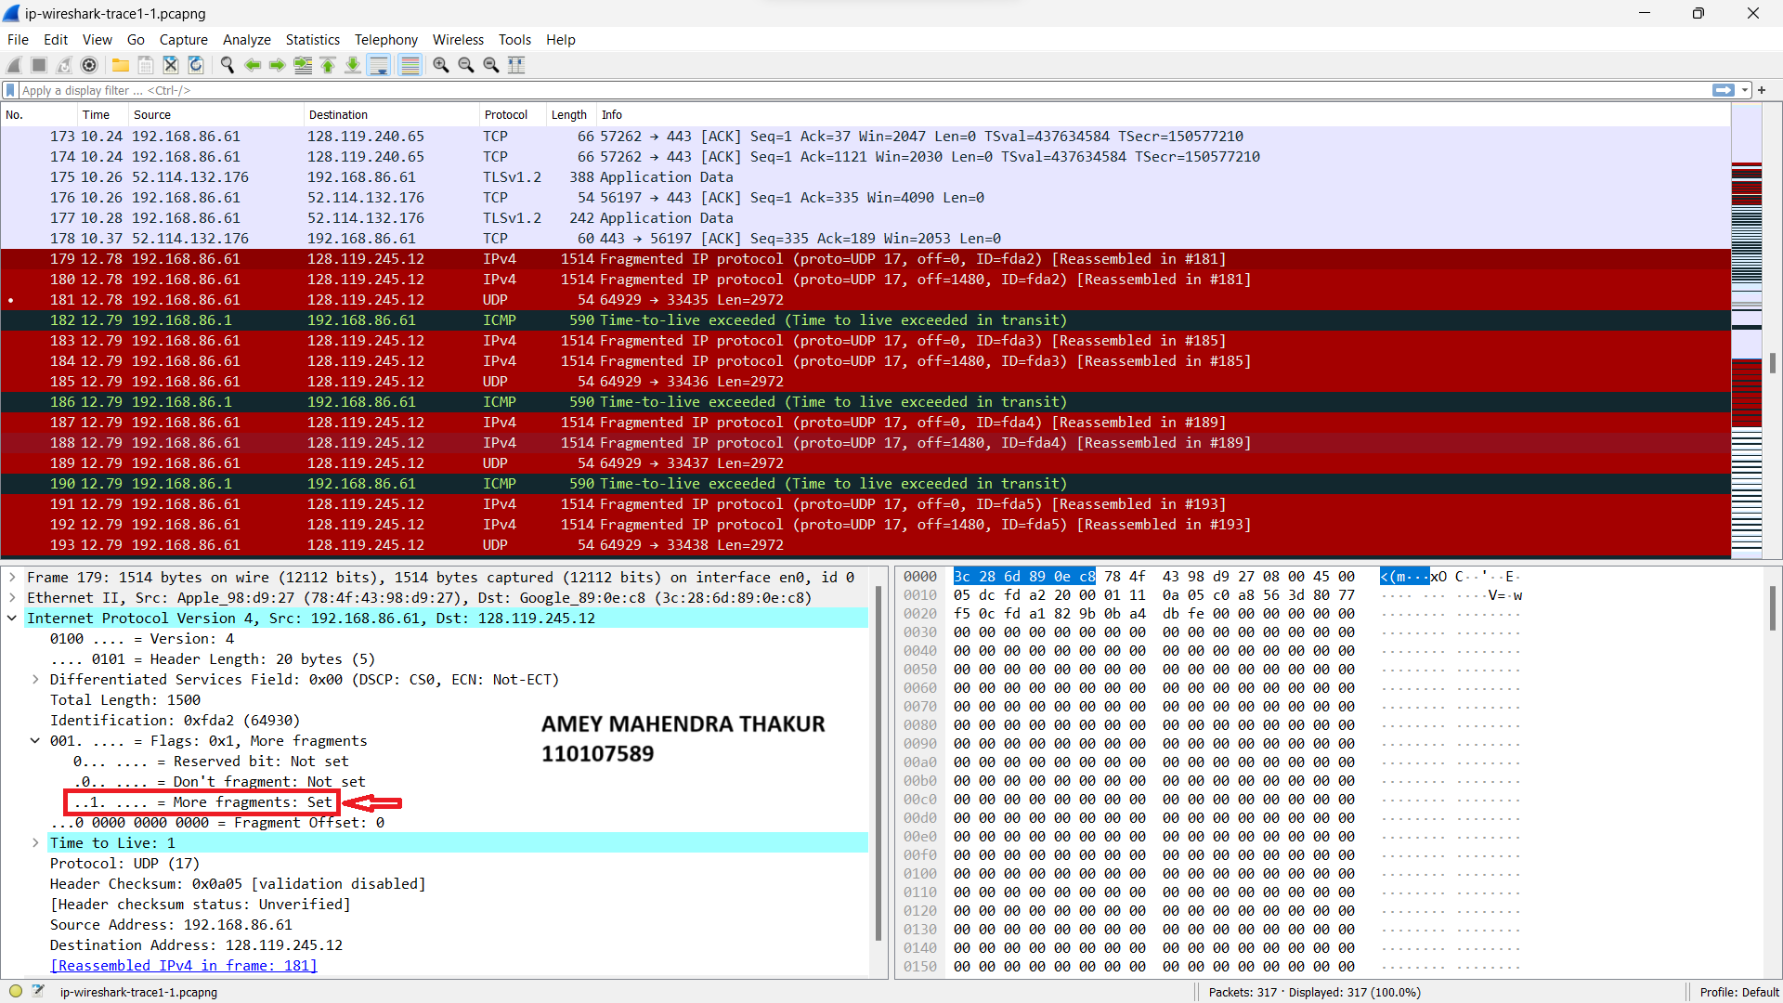

1. If the “fragment offset” value is 0, then it indicates that this is the first fragment versus latter fragment.

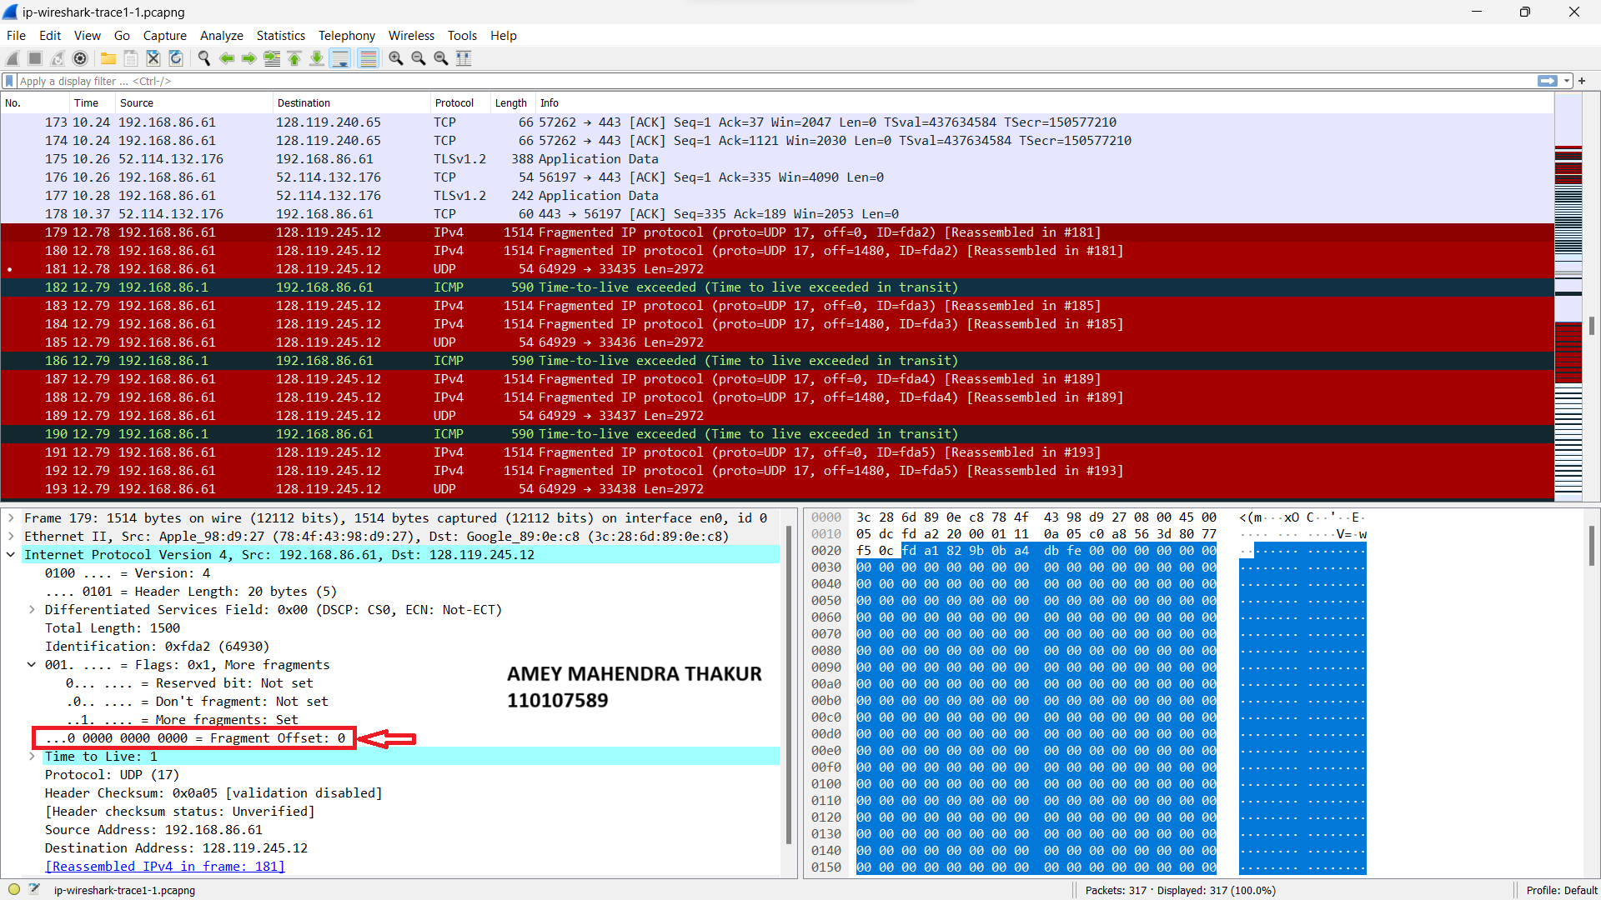

1. The total length of the datagram = 1500 bytes

The length of header = 20 bytes

The length of data = 1480 bytes

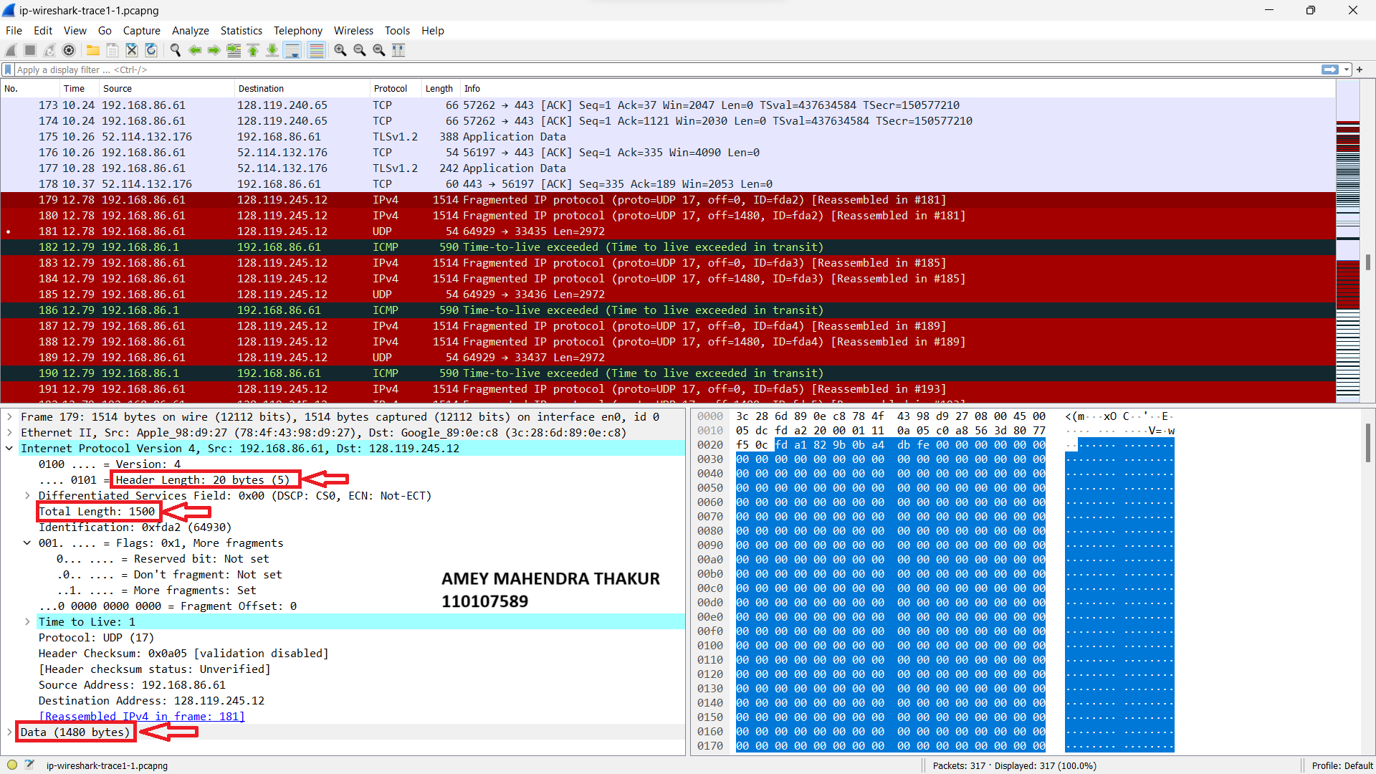

1. In the below screenshot, “Fragment Offset” set to 1480 indicates that this is the second fragment of the fragmented UDP segment.

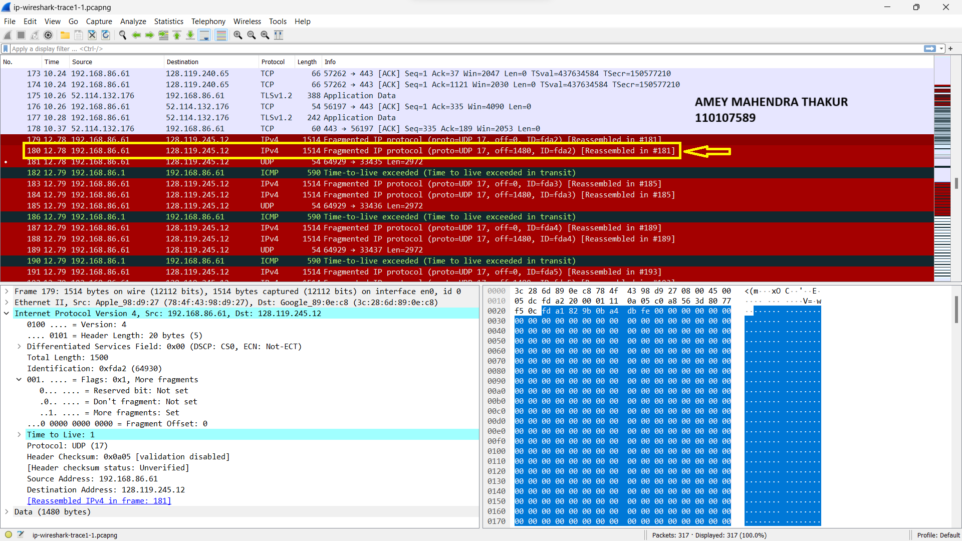

1. When observed the 3 fragments, I have seen the header checksum and fragmentation fields are changing.

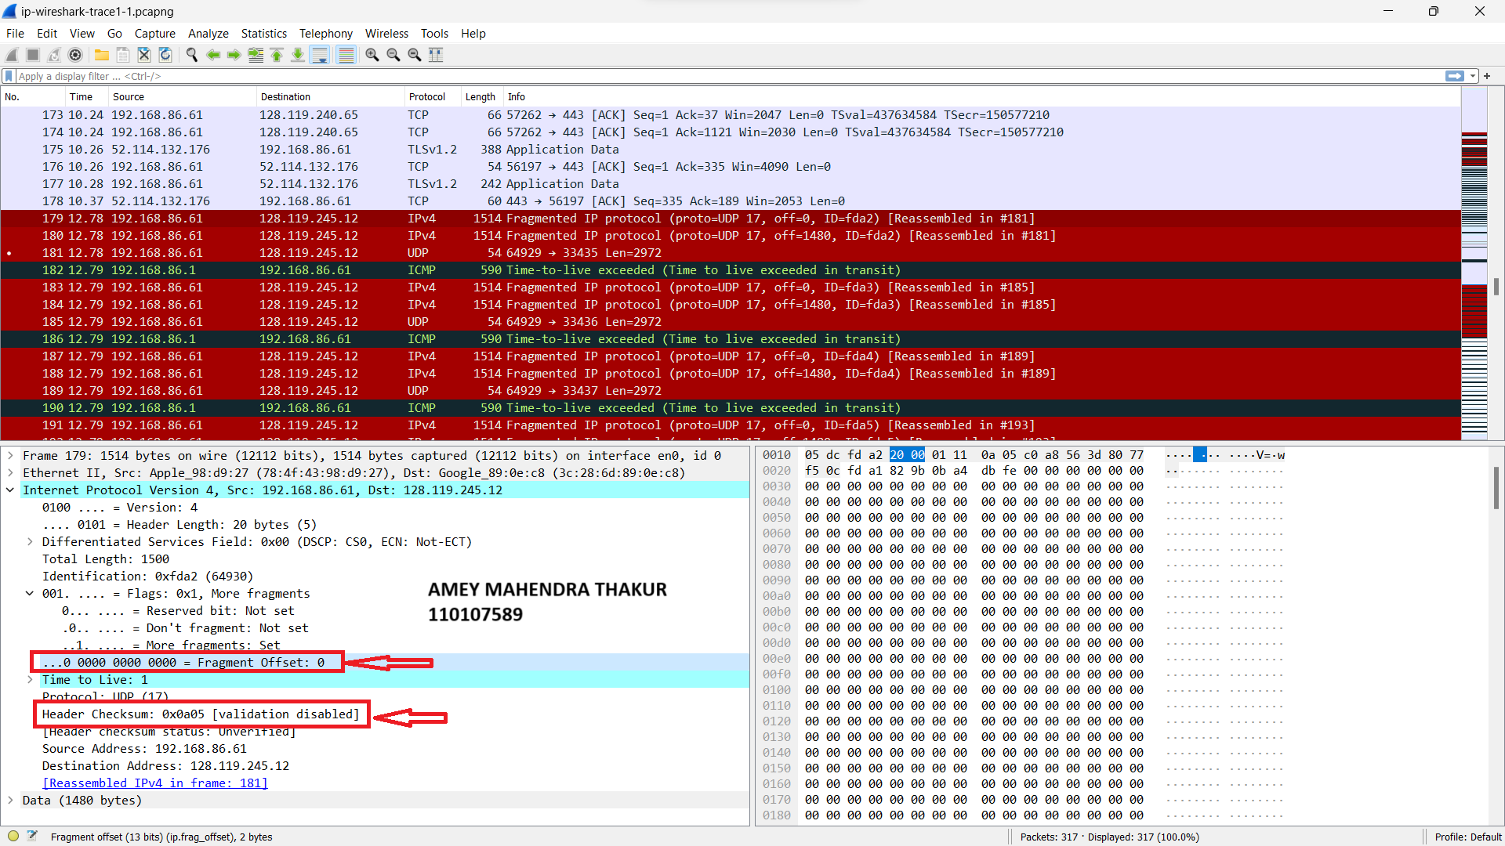

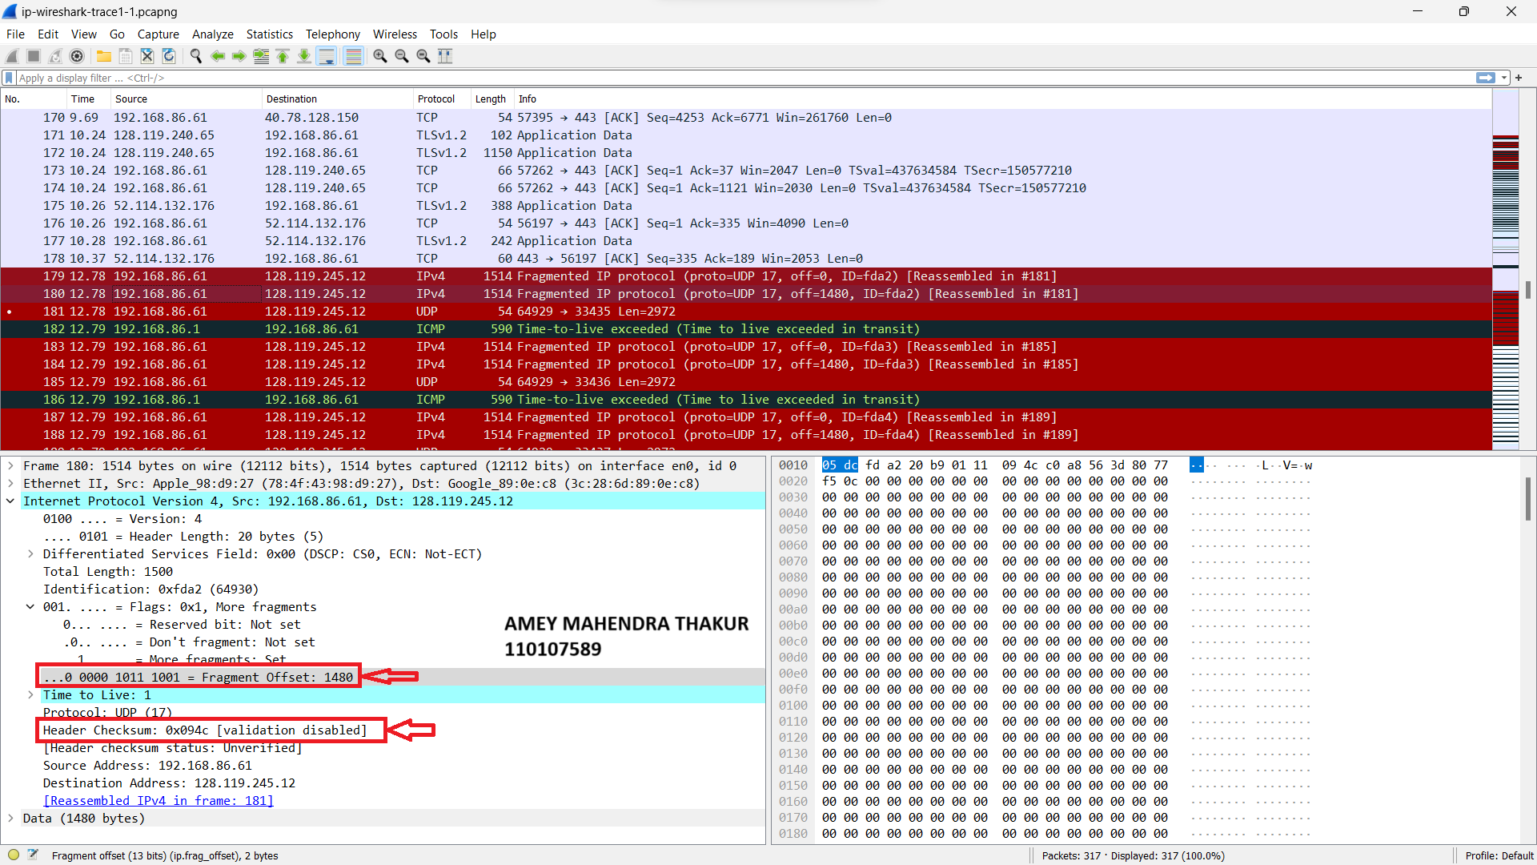

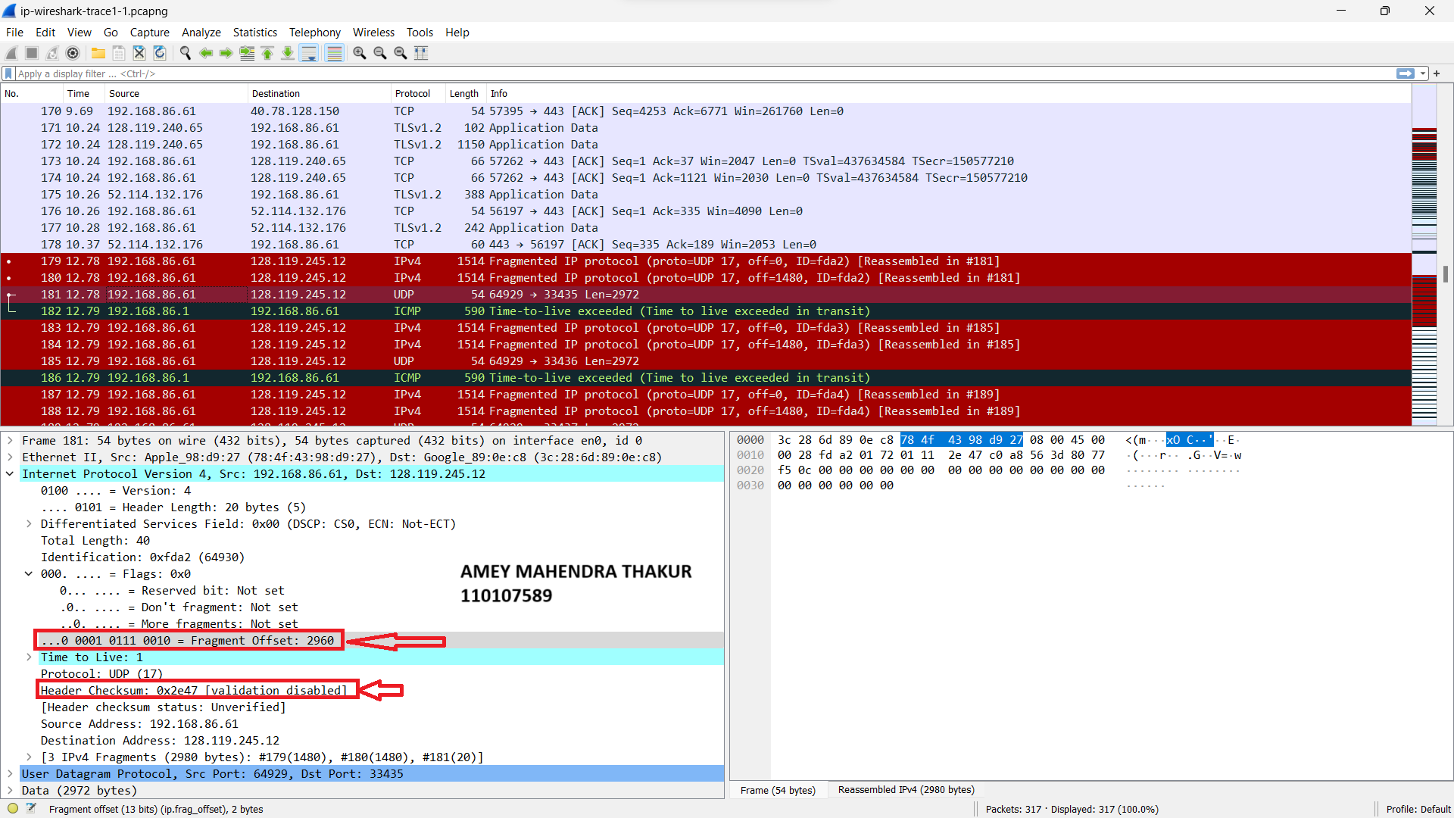

1. If the value of “more fragments” flag is 0, then that fragment will be considered as the last fragment, and it cannot be fragmented further. And, the value of identification field in this fragment is same as the first two segmented fragments, which indicates that this belongs to original datagram.

